International Negotiations
1st and 2nd Languages
Nemzetközi tárgyalások technikája 1. és 2. Nyelv

Teacher: John Kowalchuk
Office: 202
Email: jkowalch@sze.hu
Telephone: 96/ 503 400 ext. 3172

Course Objective:
To introduce students to the theories, processes and practises of International Negotiations.

Course Overview:
This course is designed to teach students the theoretical background of International Negotiations then apply those theories to practical situations. During the semester the students will attend lectures regarding the different aspects of International Negotiations. They will then be required to participate in ‘case studies’ putting the theories into use in practical and real life situations.

Course Outline:
- Introduction
The expectations of the students and the structure of the course. Define negotiations and go through the different types of negotiations.

- Review basic negotiation skills
Go through the basics of negotiations: the structures, the elements and basic strategies and tactics.

- Global Negotiations
Examine the elements of culture, national differences, cultural and behavioural traits that will affect an international negotiation. Overviews of how to effectively research other cultures to better understand the counterpart’s cultural background.

- Interaction and influences
Focus on how different nationalities and cultures can relate, can conflict and can agree.

- Characteristics of situations
Examine the immediate external and cultural factors that will influence the negotiation procedures. This includes: location, participants, time limits, physical arrangements, and status differences

- Stages of International Negotiations
Define and examine the stages of international negotiations:
Planning
Relationship Building
Exchanging information
Persuading
Concessions and agreement

- International Negotiation tactics and strategies
Examine various tactics and strategies of negotiations the advantages and disadvantages of each in various settings and environments.

- Dynamics of International Negotiations

Balance of power
Long term and short term results
Creating a win-win feel

- Context of International Negotiations
Examine how international negotiations relate to and are influenced by certain external factors some of which include: legal, political, business, society, ideologies, cultural.

- International Negotiation techniques and secrets
Other tactics of negotiating and how to deal with different negotiating personalities. Also focusing on how to achieve your own goals effectively in the negotiating process.

- Ethics of International Negotiations
Examine the moral consequences of lying and bluffing within the negotiating process.

- International Negotiations with mediators and translators
How to effectively use mediators and translators and examine common problems that occur if they are present in a negotiation.

- Final test and course evaluation

Distribution of Marks:
Exam Course

Mark Breakdown
Mark | Percentage
5 | 100-90
4 | 89-80
3 | 79-70
2 | 69-60
1 | 59-0

Course Text:
Notes provided by teacher.

Recommended Reading:
Auer, J. T., 1989, The Joy of Selling, Toronto, Canada: Stoddart Publishing Company.

Ghauri, Pervez N. & Usunier, Jean-Claude, 2005, International Business Negotiations, 2nd Edition, Oxford, UK: Peramon.

Jones, Leo & Alexander, Richard, 1996, New International Business English, 2nd Edition, Cambridge: Cambridge University Press.

(Lewicki, R. Sauders, D. & Minton, J., 1999, Negotiation: Readings Exercises and Cases, 3rd Edition, Boston, MA: Irwin McGraw-Hill.)

Additional Information:

In taking this course you agree that if you copy, cheat, or plagiarize on any of the assignments, projects, test or course work, you will receive a final mark/grade of 1 (elégtelen) as a final mark for the course.

In taking this course you argree that having part time or full time employment is no excuse for not completing any of the course work (including class participation) nor is it an excuse for doing any of the course work past the due date.

Late assignments will be accepted at one full mark/grade lower for every 24 hours late past the deadline.

Distributive Bargaining

http://www.culture-at-work.com/contents.html#culture
Distributive bargaining occurs when there is a fixed pie, a finite limit to a resource, and negotiators have to decide who gets how much of that pie. This type of negotiation is transactional, and deals with the tangible aspects of a deal.
By definition, it is zero sum--when I win, you lose.
Even in more complex multi-issue, multi-party, or interest-based negotiations, there is nearly always a portion of the issues on the table that concern the distribution of fixed resources.

Basic Terms
Dolores wants to buy a used Accounting For Aces textbook. The bookstore is selling used copies for $90. She hopes to get one for $60 but is willing to pay up to $80 for one in good condition.

Benjamin has posted a note advertising his used Accounting for Aces text for $90. He can sell it back to the bookstore for $65, so he won't go lower than that price.
Delores comes to inspect it, and because the book has almost no highlighting, she offers $65, and soon they settle at $75.

Initial offer point

This is your opening offer that you will lay on the table when entering the negotiations, it is your best expectation. In this example Dolores’ initial offer point might be $60 or even a little lower, possibly $55. On the other hand Benjamin’s initial offer point would probably be $90. Benjamin couldn’t really ask for more as the book store already sells used copies for $90 therefore he would probably get no offers. It is important to note that your initial offer may never be heard if the other party puts their initial offer first and that is the starting point to the negotiation.

Target or aspiration point
This is a realistic goal or expectation, considering that the other party will not want to give you everything. It is an acceptable outcome. In the example Dolores' is probably $65, Benjamin's is $85. It is always important that your target is a little lower than your offer otherwise your opponent will feel you are not willing to negotiated and they will not gain anything within the negotiation.

BATNA -- Best Alternative to a Negotiated Agreement
What do you do if you can't reach an acceptable deal? Dolores' BATNA is to share a text with her roommate. Benjamin's is to wait and see if a more generous buyer shows up or to sell the text to the bookstore. The BATNA is a positive perspective that focuses on your options.

Reservation point (Resistance point)
The point beyond which you will not accept a deal and will turn to your BATNA. The reservation point is the quantification of BATNA, the trigger point where you will take your next best alternative instead of negotiating. (Informally, this is often called "your bottom line") Dolores' reservation point is $80, Benjamin's is $65.

Bargaining Zone
The range between the buyer's high and the seller's low. In this case between $65 and $80. This is a positive bargaining zone. A negative zone occurs when there is no overlap (say Benjamin would only sell for $90 or more, and Dolores wouldn't go higher than $85. BATNA time!)

Bargaining surplus

A measure of how wide the positive zone is -- in this case $15, which gives a relatively large area for mutually successful bargaining.

Negotiator's surplus
The amount of the positive bargaining zone a negotiator takes home. For Dolores it is $80-$75=$5. For Benjamin it is $75-$65=$10.

Suboptimal deals or "leaving money on the table"
When parties fail to capitalize on a positive bargaining zone where both sides could have met their goals, or miss other opportunities for mutual gain. In this case, the bargaining zone is large enough that even incompetent negotiators will probably find a price within it. If the zone is quite small, however, (Say Dolores has the option of a $70 edition with slightly more marks on it.) the negotiators may decide erroneously that there's no way they can reach agreement. Don't confuse this term with your disappointment in not capturing the entire bargaining surplus for yourself!

Bargaining Zone Model of Negotiations
©Richard D. Irwin, Inc., 1992

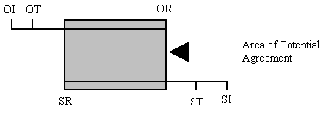

OI = Opponent’s Initial Offer Point
OT = Opponent’s Target Point
OR = Opponent’s Resistance Point

SI = Self Initial Offer Point
ST = Self Target Point
SR = Self Resistance Point

Example:
For the example given above:
(The “Opponent” in this case is Dolores the buyer)

OI = $55
OT = $60
OR = $80

(The “Self” in this case is Benjamin the seller)

SI = $90
ST = $85
SR = $65

Long Term / Short Term Planning:

 |  | Is the substantive outcome very important to the manager/negotiator?
 |  | YES | NO
Is the relationship very important to the manager/ negotiator? | YES | Trusting Collaborate  Both the outcome and relationship are important to both parties  Win – Win ⇒ long term | Openly subordinate (accommodate)  Relationship is important, one party is willing to give up more in order to have a long term relationship  Yield – Win ⇒ long term
 | NO | Firmly Compete  Substantive outcome is important for both parties, no one cares about the long term relationship  Win – Lose ⇒ short term | Active Avoid (withdraw)  Neither outcome or the relationship is important to both parties  Lose – Lose ⇒ short (no) term

Negotiating Globally
Individual Characteristics

Communication
Emotionalism
Risk Taking
Buyer/Seller Relationship

Situational Contingencies
Location
Physical Location
Participants
Time Limits
Status
Personal Style

Strategical and Tactical Processes

Context of International Business Negotiations

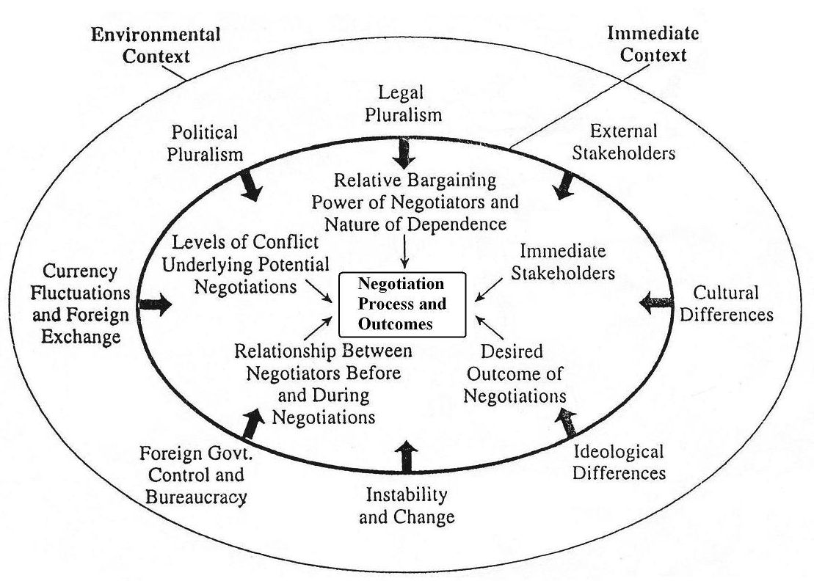

Sources

http://www.culture-at-work.com/contents.html#culture

Auer, J. T., 1989, The Joy of Selling, Toronto, Canada: Stoddart Publishing Company.

Ghauri, Pervez N. & Usunier, Jean-Claude, 2005, International Business Negotiations, 2nd Edition, Oxford, UK: Peramon.

Lewicki, R. Sauders, D. & Minton, J., 1999, Negotiation: Readings Exercises and Cases, 3rd Edition, Boston, MA: Irwin McGraw-Hill.

